**User Guide**

The game is an interactive quiz on Cloud Computing concepts. It is designed to challenge players to answer a series of questions on various topics relating to cloud computing. As players progress, they level up, earning various achievements along the way.

**Game Screens**

The opening Screen is the Welcome Screen:

1. Enter Username in the first field.
2. Enter password in the second field.
3. Click on 'Login'.
4. If wrong details are entered, a message: 'Invalid username or password' is displayed. Please try again with correct details.



Upon successful login with player logging in, The Player screen opens:

1. User's nickname and level are presented on the left-most top corner with a bronze, silver or golden medals for each level. Also, the player's point level is presented.
2. Click on "Select topic" for topic selection.
3. If you wish to return to the Welcome Screen, click the exit button "X" on the right-most top corner.

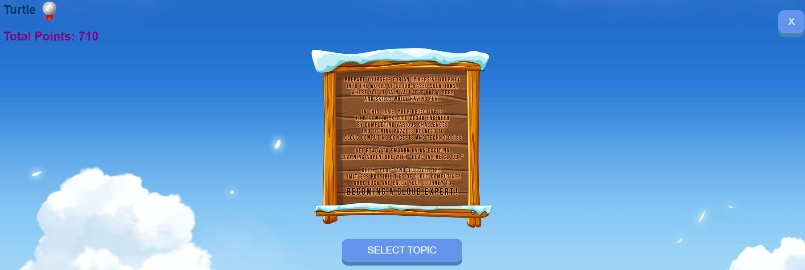

The Topic Selection screen is displayed, and players can select a topic for the quiz.

1. Click on the desired topic from the topic list.
2. If you wish to return to the Player Screen, click the exit button "X" on the right-most top corner.



The Quiz Screen is presented:

1. Click on the answer you consider as right.
2. If player is correct, answer will be highlighted in green, and the player score is increased.  
   
3. If player is mistaken, the wrong answer is highlighted in red, and the right answer is highlighted in green.
4. Click "Next" to display the next question and view the progress bar grow.



1. Keep answering until 10 questions are answered. The player is automatically transitioned to the game statistics screen.
2. Click "Back" to view the player screen.
3. Click "Try Again" to view the topic selection screen.

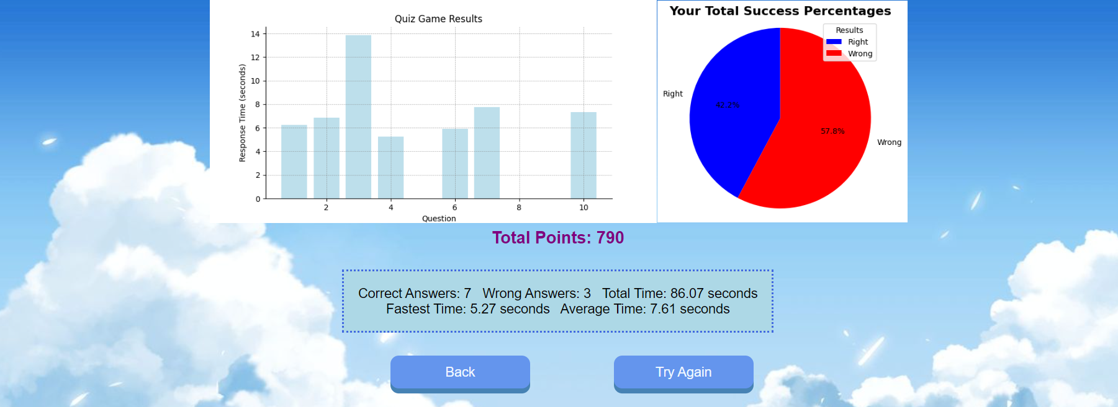

Upon successful login with manager logging in, The manager screen opens:  
  


Add Quiz:

1. Click on "Add Quiz" button on the manager screen.
2. Enter a question in the Question field.
3. Enter 4 possible answers. Make sure only one is correct.
4. Choose a topic the question relates to
5. Define which answer is correct.
6. Click "Submit"
7. If you wish to return to the Manager Screen, click the exit button "X" on the right-most top corner.



Remove Quiz:

1. Click on "Remove Quiz" on the manager screen.
2. Choose the topic of the question you wish to remove using the dropdown.
3. Click the "Remove" button next to the desired question.
4. If you wish to return to the Manager Screen, click the exit button "X" on the right-most top corner.

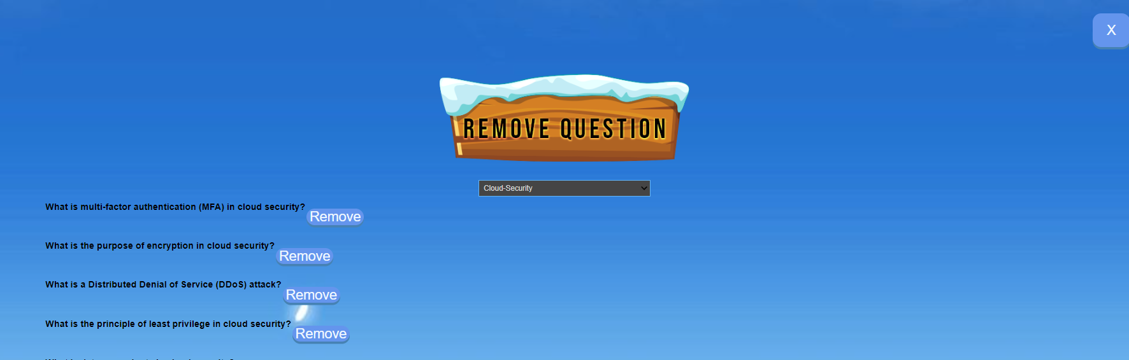

Update Question:

1. Click on "Update Quiz" on the manager screen.
2. Choose the topic that the question you wish to update relates to
3. Choose the question you wish to update from the dropdown.
4. The 4 possible answers will be visible, make the relevant corrections.
5. Define the correct answer in the last text field.
6. Click "update".
7. If you wish to return to the Manager Screen, click the exit button "X" on the right-most top corner.



**Transitions between Screens**

Transitions between screens are mainly handled by button clicks.  
Clicking the "Play" button on the Welcome Screen leads to the Player Screen.  
The "Select Topic" button on the Player Screen transitions to the topic-Selection Screen.  
Each topic button on the Selection Screen starts a quiz on the respective topic.  
After the quiz, the player is taken to the End Game Screen. In addition, there are "exit" buttons on each screen (excluding the Welcome Screen), which return to the previous screen.

**Explanation of Possible Mistakes**

1. **Username/Nickname Missing**  
   Players must enter a username and a nickname before starting the game. An error message will be displayed if one or both fields are left empty.
2. **Unsaved Progress**  
   Google Colab does not save variable values between sessions. If a player closes the game midway and reopens it later, their progress will be lost.
3. **Firebase Connection**  
   If the Firebase connection fails, the player's scores and progress will not be saved. Ensure you have a stable internet connection.
4. **Google Colab Session**  
   Google Colab disconnects after a period of inactivity. In case of a disconnection, you may need to rerun some cells to reinitialize the game.